#### Lab Assignment 9

#### Name: M Jeyapathy

#### usn: 22btrad016

#### Question 1:

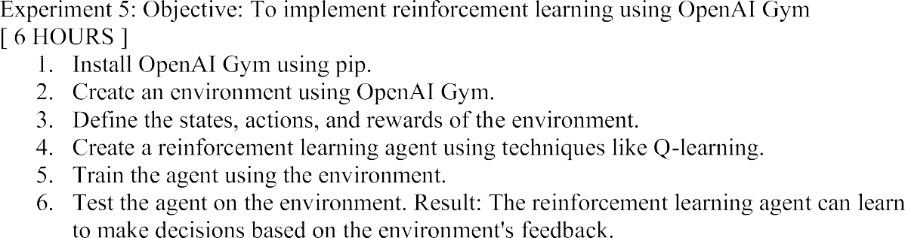

1. Install OpenAI Gym using pip.

CODE:

pip install gym

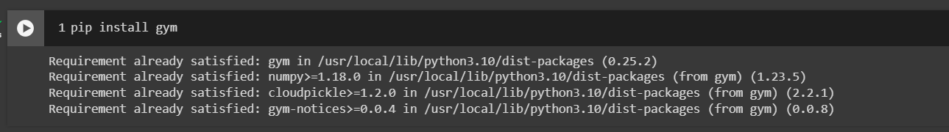

1. Create an environment using OpenAI Gym.

CODE:

import gym

import numpy as np

# Choose an environment, for example, CartPole

env = gym.make('CartPole-v1')

# Print the environment details

print(f"Observation Space: {env.observation_space}")

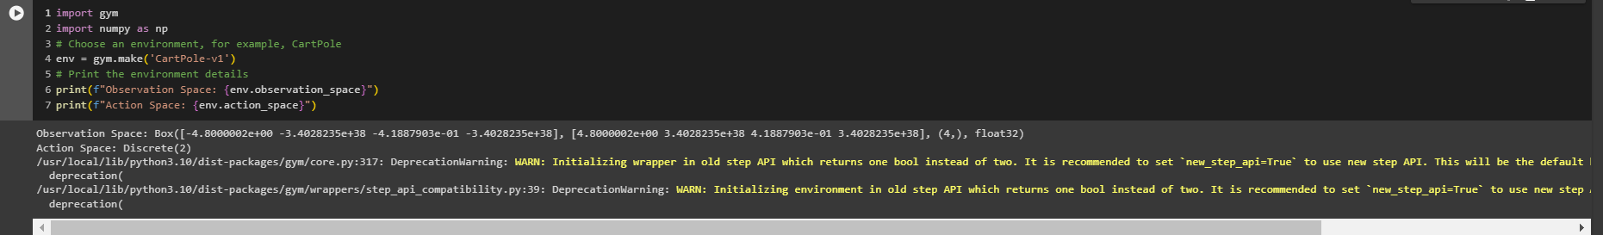print(f"Action Space: {env.action_space}")

1. Define the states, actions, and rewards of the environment

**CODE:**

# Inspect the state and action spaces

print(f"Observation Space Low: {env.observation_space.low}")

print(f"Observation Space High: {env.observation_space.high}")

print(f"Action Space N: {env.action_space.n}")

# Run a few episodes to understand the reward structure

for _ in range(3):

state = env.reset()

total_reward = 0

while True:

# Random action for exploration

action = env.action_space.sample()

next_state, reward, done, _ = env.step(action)

total_reward += reward

# Print the state, action, reward for each step

print(f"State: {state}, Action: {action}, Reward: {reward}, Done: {done}")

state = next_state

if done:

break

print(f"Total Reward: {total_reward}")

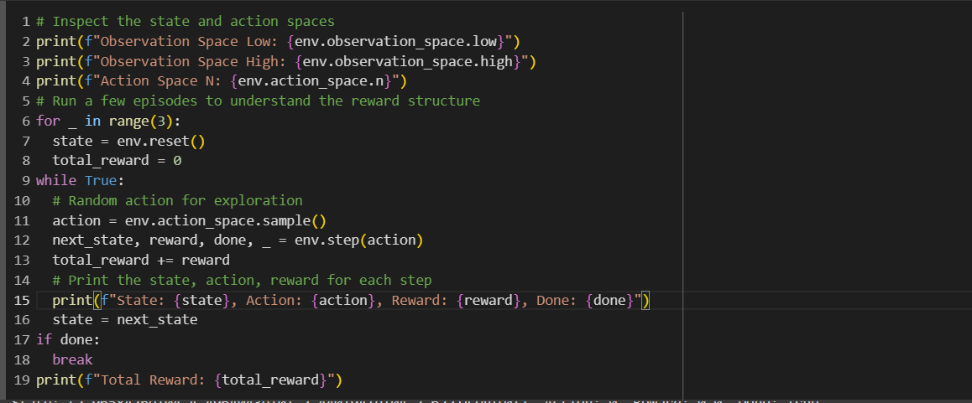

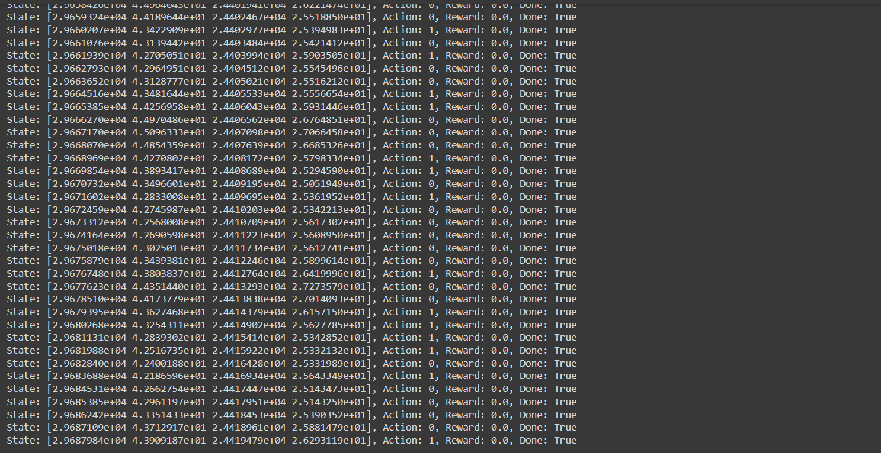

1. Create a reinforcement learning agent using techniques like Q-learning.

**CODE:**

import numpy as np

class QLearningAgent:

def __init__(self, state_space_size, action_space_size, learning_rate=0.1, discount_factor=0.99,

exploration_prob=1.0, exploration_decay=0.995):

self.learning_rate = learning_rate

self.discount_factor = discount_factor

self.exploration_prob = exploration_prob

self.exploration_decay = exploration_decay

self.action_space_size = action_space_size

# Discretize the state space

self.state_space_bins = [np.linspace(env.observation_space.low[i], env.observation_space.high[i],

num=10) for i in range(state_space_size)]

# Initialize Q-table with discrete state space

self.q_table = np.zeros(tuple(len(bins) - 1 for bins in self.state_space_bins) + (action_space_size,))

def discretize_state(self, state):

return tuple(np.digitize(state[i], self.state_space_bins[i]) - 1 for i in range(len(state)))

def choose_action(self, state):

state = self.discretize_state(state)

if np.random.rand() < self.exploration_prob:

return np.random.choice(self.action_space_size)

else:

return np.argmax(self.q_table[state])

def update_q_table(self, state, action, reward, next_state):

state = self.discretize_state(state)

next_state = self.discretize_state(next_state)

best_next_action = np.argmax(self.q_table[next_state])

self.q_table[state + (action,)] += self.learning_rate * (reward + self.discount_factor *

self.q_table[next_state + (best_next_action,)] - self.q_table[state + (action,)])

# Decay exploration probability

self.exploration_prob *= self.exploration_decay

# Assuming you know the state and action space sizes

state_space_size = env.observation_space.shape[0]

action_space_size = env.action_space.n

agent = QLearningAgent(state_space_size, action_space_size)

# Print initial Q-table

print("Initial Q-table:")

print(agent.q_table)

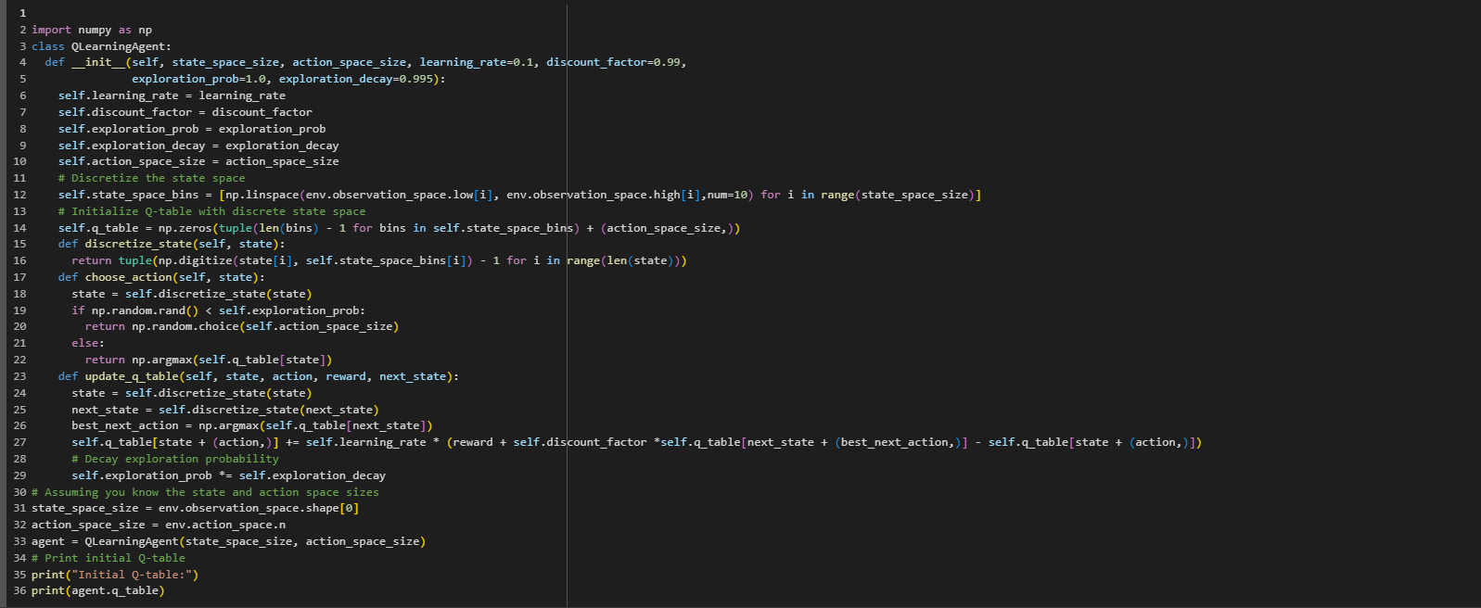

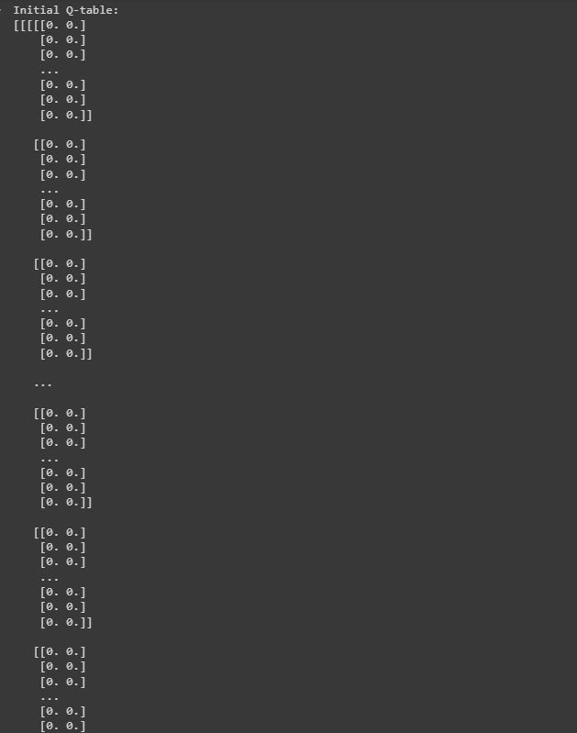

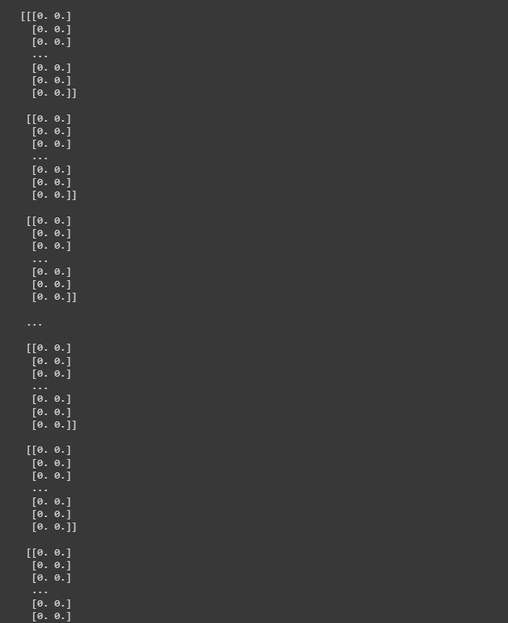

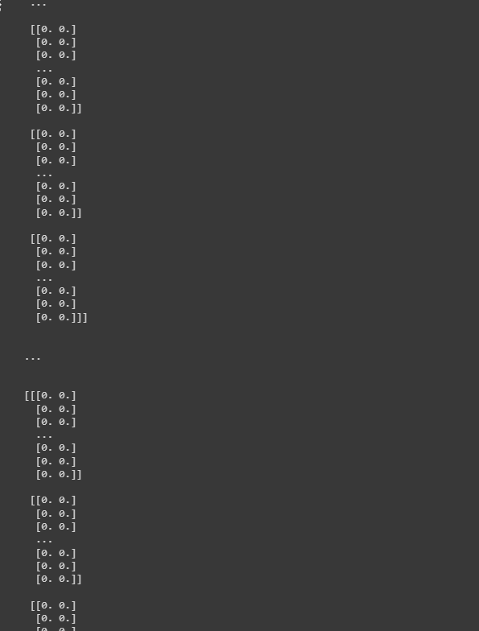

1. Train the agent using the environment**.**

**CODE:**

num_episodes = 1000

for episode in range(num_episodes):

state = env.reset()

total_reward = 0

while True:

action = agent.choose_action(state)

next_state, reward, done, _ = env.step(action)

agent.update_q_table(state, action, reward, next_state)

total_reward += reward

state = next_state

if done:

break

# Print the total reward for each episode during training

print(f"Episode: {episode + 1}, Total Reward: {total_reward}")

# Print the final Q-table after training

print("Final Q-table after training:")

print(agent.q_table)

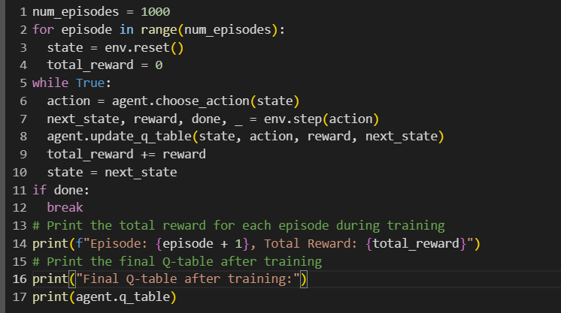







6. Test the agent on the environment. Result: The reinforcement learning agent can learn to make decisions based on the environment's feedback.

**CODE:**

num_test_episodes = 10

for episode in range(num_test_episodes):

state = env.reset()

total_reward = 0

while True:

action = agent.choose_action(state)

next_state, reward, done, _ = env.step(action)

total_reward += reward

state = next_state

if done:

break

# Print the total reward for each episode during testing

print(f"Test Episode: {episode + 1}, Total Reward: {total_reward}")

env.close()

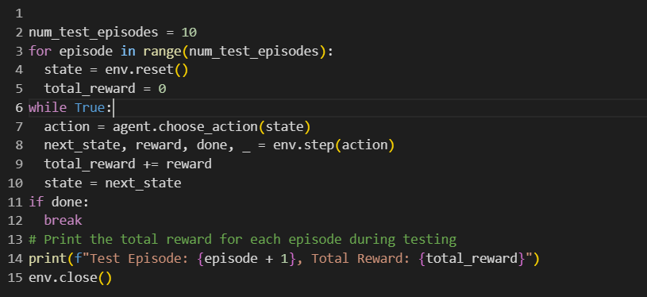

Github Link:

https://github.com/Jeyapathy/Machine-Learning